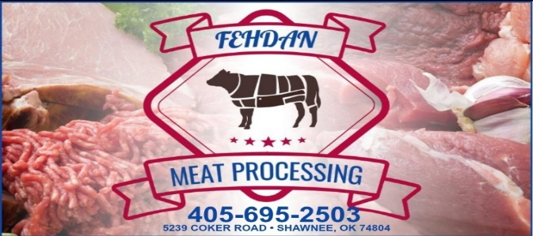

NAME:_________________________________________PHONE:____________________________
BEEF HCW:____________________LBS WHOLE BEEF ½ BEEF ¼ BEEF
_________________________________________________________________________________
_________________________________________________________________________________

ROUND STEAK:___________________________________________________________________
SIRLOIN STEAK:___________________________________________________________________
T-BONE STEAK:___________________________________________________________________
CLUB OR RIBEYE:__________________________________________________________________
ARM ROAST:_____________________________________________________________________
CHUCK ROAST:___________________________________________________________________
SHORT RIBS:_____________________________________________________________________
STEW MEAT:_____________________________________________________________________
SOUP BONE:_____________________________________________________________________
ROMP ROAST:____________________________________________________________________
PIKES PEAK:______________________________________________________________________
LOIN TIP:_________________________________________________________________________
GROUND BEEF PACKAGES: 1# 1 ½ # 2# OTHER:_____________________________
BRISKET:_________________________________________________________________________
SKIRT FLANK LIVER HEART TONGUE OXTAIL
NOTES:__________________________________________________________________________
________________________________________________________________________________

